CS 255 System Design Document Template

UML Diagrams

UML Use Case Diagram
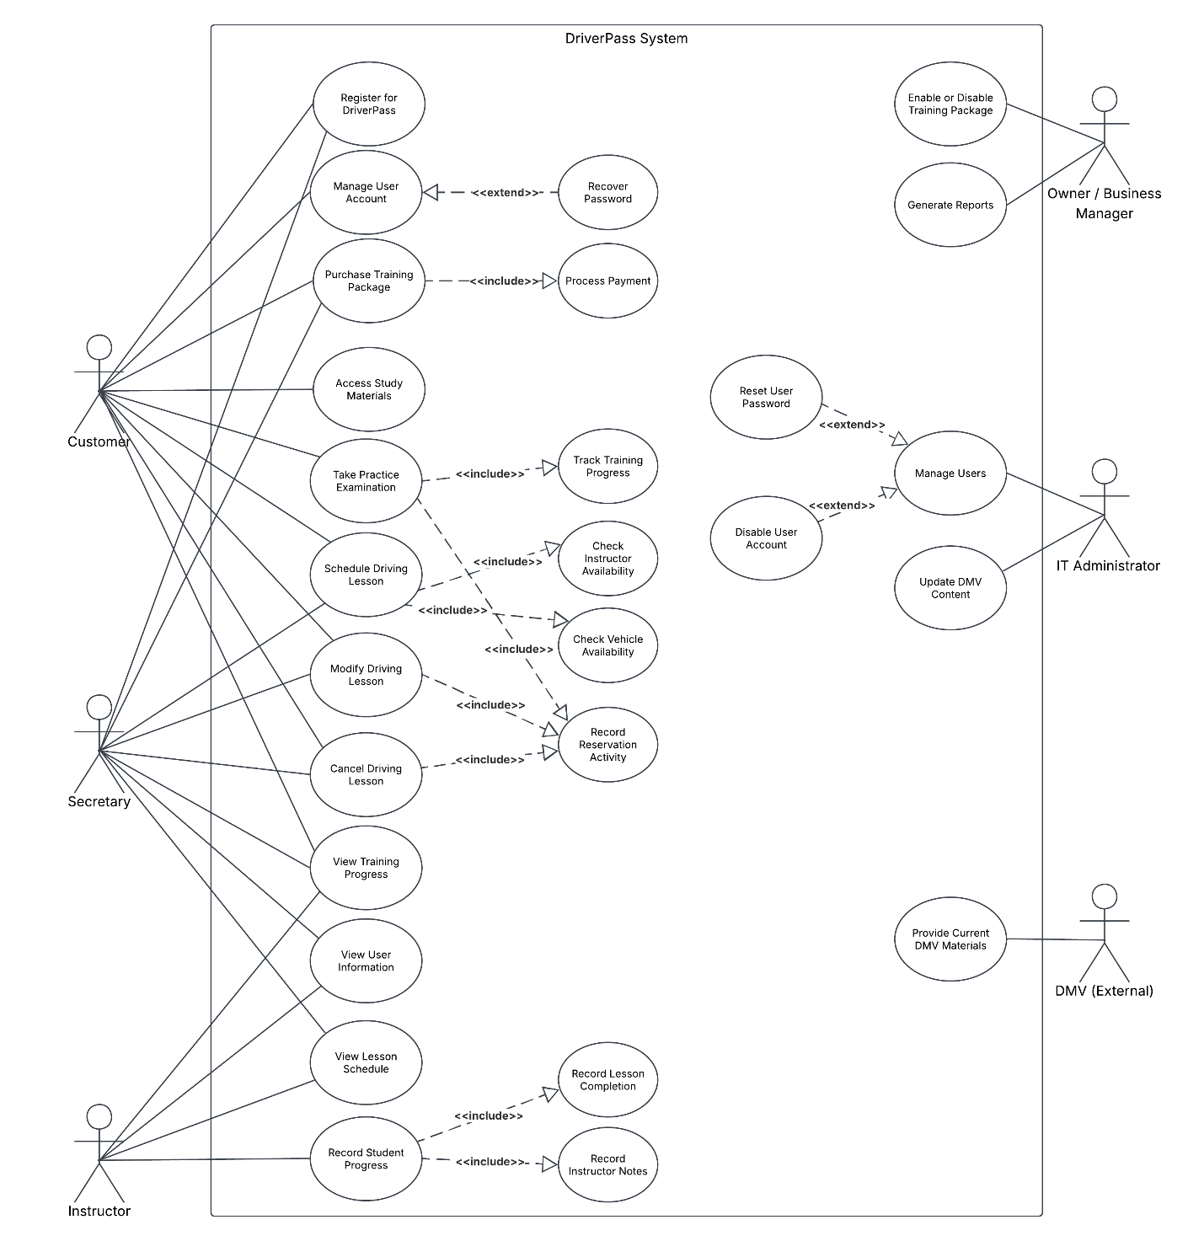

UML Activity Diagrams
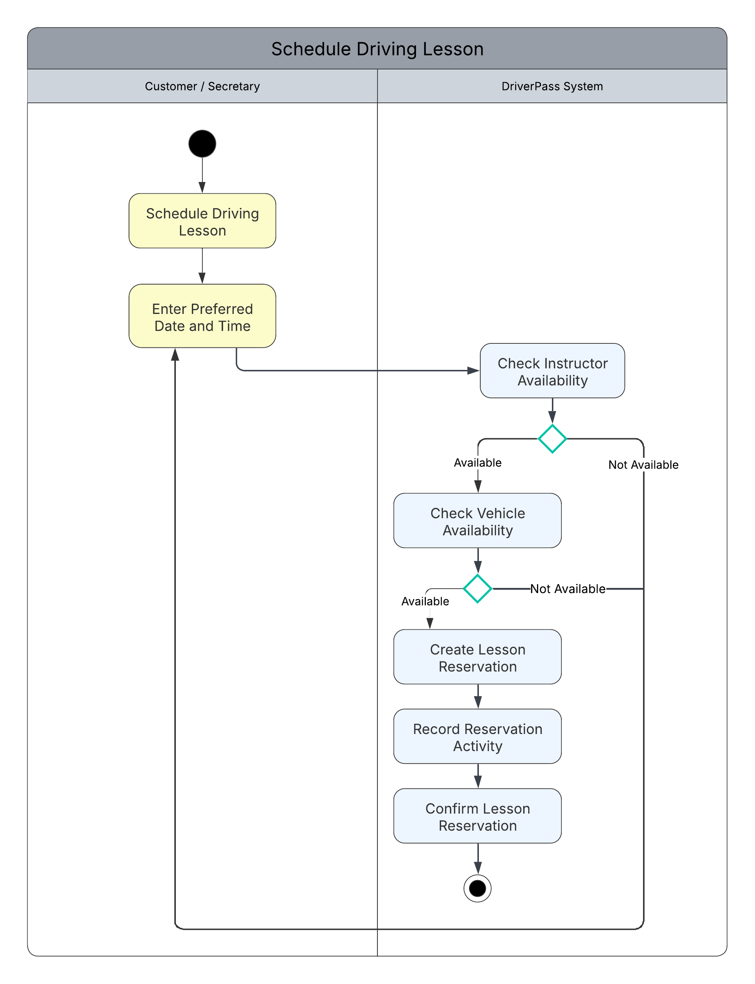
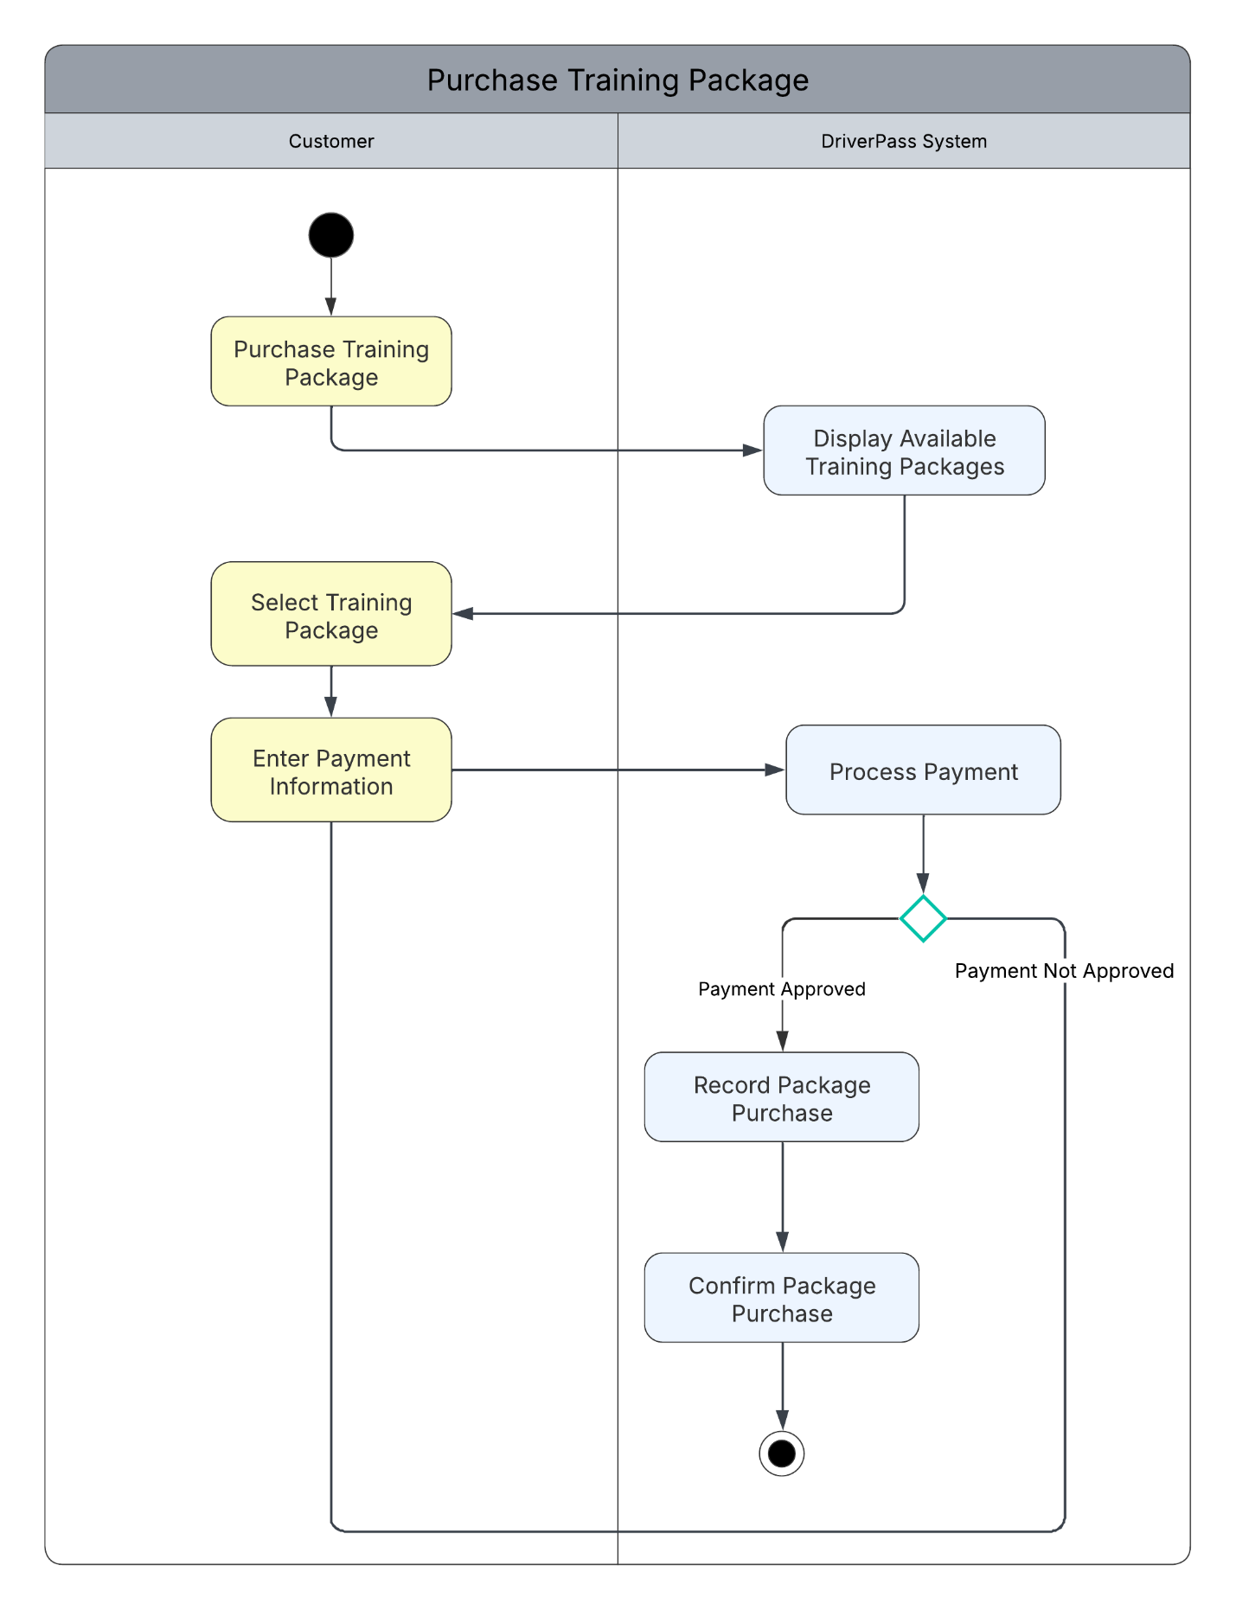

UML Sequence Diagram
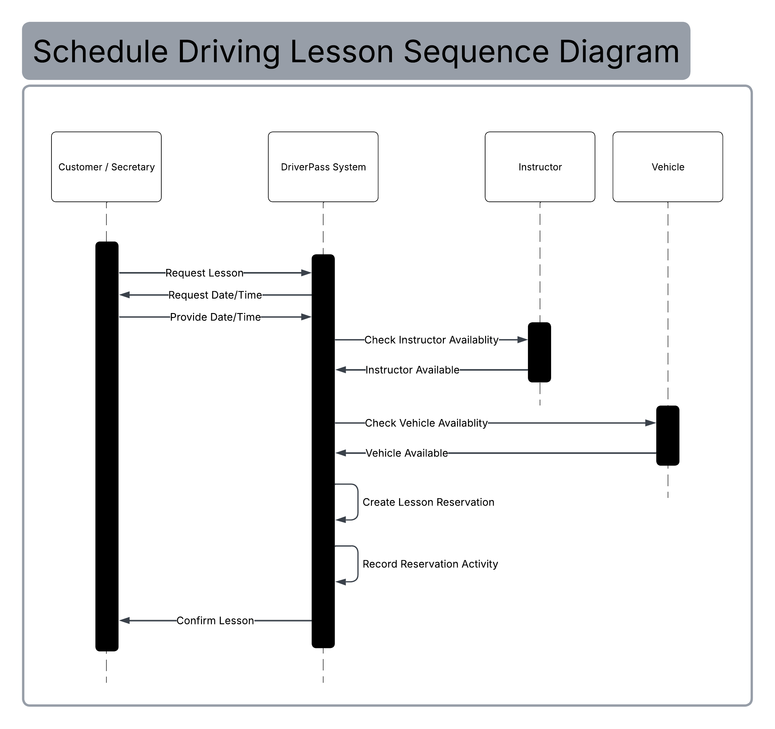

UML Class Diagram
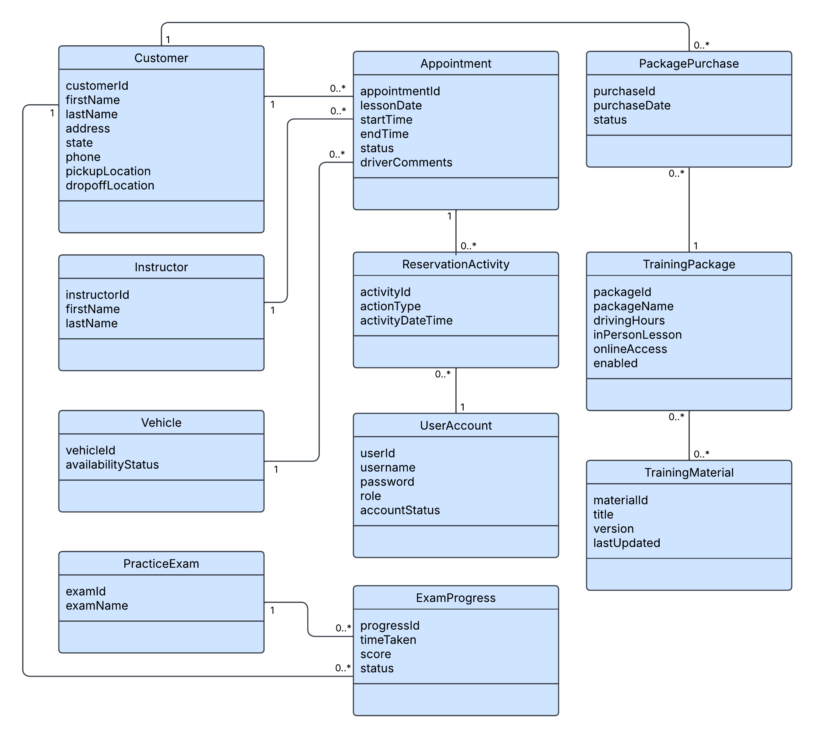

Technical Requirements
The DriverPass system will require a cloud-based infrastructure that supports a web application and a centralized relational database. Customers and DriverPass employees will access the system through internet-connected desktop computers, laptops, tablets, or mobile devices using a current web browser. Cloud-based hosting will minimize the need for locally maintained application-server infrastructure or specialized client hardware while providing reliable availability, security, and the ability to scale as system usage increases. The system's live data must be backed up nightly and support recovery in the event of data loss or system failure.

The software environment must support the functions represented in the system design, including user accounts, training packages and materials, practice examinations, student progress, driving lesson appointments, instructor and vehicle availability, package purchases, and reservation activity. The centralized relational database must support multiple concurrent users while maintaining accurate customer, scheduling, training, and progress information. The web interface should support current major browsers and provide a responsive interface for both desktop and mobile devices.

Development and design tools should support web application development, relational database design, version control, testing, and UML modeling. A UML modeling tool such as Lucidchart can be used to maintain the system design diagrams, while an integrated development environment and version control system can support implementation, testing, and collaborative development. Specific programming languages, database management systems, and development platforms can be selected during implementation based on the final technical architecture rather than being required by the current system design.

Security requirements include secure user authentication, encrypted communication between clients and the server, and role-based access control for the different types of DriverPass users. User credentials and other sensitive account information must be protected. The system must also support password recovery and temporarily lock a user account after five consecutive unsuccessful login attempts. Authorized IT administrators must be able to reset passwords, unlock accounts, and disable user accounts. Reservation activity should be recorded so that DriverPass can identify the user responsible for creating, modifying, or canceling an appointment.

The infrastructure must support secure communication between the web application and database and allow authorized users to access the system from outside the DriverPass office. The system must also support updates to DMV rules, policies, training materials, and practice examination information as new DMV content becomes available. During normal operating conditions, common system requests should return within three seconds while supporting multiple simultaneous users without creating scheduling conflicts or duplicate records.

